FACULTY OF PHARMACEUTICAL SCIENCES
DEPARTMENT OF PHARMACEUTICAL MICROBIOLOGY AND BIOTECHNOLOGY
MICROBIAL CHEMOTHERAPY AND BACTERIAL GENETICS
(PMB 571)
(ANTIFUNGAL AND ANTIVIRAL AGENTS)

DR. CHIBUNDO OKORIE
AGENTS OF ANTIFUGAL CHEMOTHERAPY

1.1 Introduction
1.1.1 Classification of Fungi
1.1.2 Types of fungal infections
1.2 Antifungal agents
1.2.1 Agents that bind to ergosterol
1.2.2 Inhibitors of ergosterol synthesis
1.2.2.1 Azoles
1.2.2.2 Allylamines
1.2.2.3 Thiocarbamates
1.2.2.4 Morpholines
1.2.3 Inhibitors of nucleic acid synthesis
1.2.4 Inhibitors of mitosis

1.1 Introduction
Fungal infections in humans are often asymptomatic, especially in immunologically sound individuals. However, if the level of infection overwhelms the immunological status of the host, clinical manifestation may appear requiring therapeutic interventions. There are few compounds for treatment of fungal infections, unlike in antibacterial chemotherapy where a wide range of antibiotics exists.
Two main reasons are:
(i) Fungal infections are less common than bacterial infections. So, they do not pose as much challenge for the research and development of newer anti-fungal drugs.
(ii) Fungal cells are eukaryotic and are more similar to mammalian cells than bacteria. Therefore it is not easy to develop highly selective anti-fungal agents that have no toxic effects on the host cells.
1.1.1. Classification of Fungi
Fungi may be classified as
Yeasts: Blastomyces, candida, histoplasma, coccidioides, cryptococcus.
Moulds: Aspergillus spp, Dermatophytes
Clinically classified as superficial mycosis and deep (systemic) mycosis

1.1.2. Types of fungal infections
I Mucocutaneous (Superficial) infections
a. Dermatophytes: cause infection of skin, hair and nails. E.g tinea capitis (scalp), tinea cruris (groin), tinea pedis (foot), onychomycosis (nails).

b. Yeasts: cause infections of moist skin and mucous membranes e.g Candida albicans causing oral, pharyngeal, vaginal and bladder infections.
- Systemic mycoses: are fungal infection affecting internal organs. It occurs in immunocompromised patients e.g. cryptococcosis and aspergillosis (lung).
1.2. ANTIFUNGAL AGENTS
An antifungal agent is a drug that selectively eliminates fungal pathogens from a host with minimal toxicity to the host.
On the basis of their chemical structures, antifungal agents can be placed in the following groups: polyenes, imidazoles , triazoles, nucleotides , allylamines, thiocarbamates, morpholines and grisans. The antifungal agent will be described under the classification based on their mechanisms of action.
Antifungal agents can be classified as follows
1.2.1 Agents that bind to ergosterol
The principal sterol in the fungal cell membrane is ergosterol. It is also present in the cell membrane of certain protozoa. Mammalian cells (including, of course, human cells) contain cholesterol. Sitosterol is found in plants. Antifungal agents that alter cell membrane act by either binding to the sterol thereby disrupting its structure, or preventing its synthesis. This is the basis of the toxicity of this group of antifungal drugs. However, only those compounds with relative selectivity for ergosterol can be used for clinical purposes. This includes largely the polyene antifungal antibiotics.
Agents that bind to ergosterol include the polyene antimycotics. The polyenes are produced by various species of streptomyces. They have cyclic lactone structures containing varied numbers of hydroxyl groups as well as conjugated double bonds ranging from two to seven in number. They are identified accordingly as diene, triene, tetraene, pentene, hexene and heptene.
Two polyene antimycotics most commonly used therapeutically are amphotericin B (produced by S. nodosus) and nystatin (produced by S. noursei). Amphotericin B possesses a greater potency in damaging fungal cells than mammalian cells. It binds more selectively to ergosterol-containing membranes than to cholesterol-containing membranes. The amphotericin B molecule inserts into the cytosolic membrane of susceptible cells, and causes an increase in the permeability of the membrane. This leads to the leakage of essential ions, particularly potassium and magnesium, from the cytosol, ultimately causing fungal death.
This action of amphotericin B is believed to be dose-dependent and, so, the drug may be fungistatic or fungicidal, depending on the concentration to which the organism is exposed. It is active against a wide range of infectious fungi, such as Candida species, Cryptococcus neoformans and Aspergillus fumigatus. There is synergism between amphotericin B and 5-fluorocytosine. The alteration of membrane permeability produced by amphotericin B facilitates the entry of 5-fluorocytosine into the cell.
Clinical use of amphotericin B is associated with severe adverse effects. These include hypokalemia, hypomagnesemia, hepatic impairment, nephrotoxicity, thrombocytopenia, anaemia and anaphylactic reactions. In order to decrease the toxicity, amphotericin B has been prepared in lipid formulations. The two commonly available forms are the liposomal amphotericin B and amphotericin B lipid complex.
Nystatin resembles amphotericin B both structurally and in its action on the cell membrane fungi. However, nystatin is not available for systemic use. At present, it is available only for topical use in the forms of creams and pessaries for the treatment of mucocutaneous and vaginal candidiasis. Given orally, as a suspension or tablet, nystatin is poorly absorbed (much like amphotericin B). It is given by the oral route for candidal infections of the oropharyngeal or gastrointestinal tract. Nystatin is also active against a variety of other fungi including Histoplasma capsulatum, Cryptococcus neoformans, Blastomyces dermatiditis, Coccidioides immitis and Aspergillus fumigatus.
1.2.2. Inhibitors of ergosterol synthesis
This is the largest group of antifungal drugs. It consists of a wide variety of chemical sub-groups such as the azoles, allylamines, thiocarbamates and morpholines. Each of these sub-groups interferes with ergosterol synthesis at different stages in the biosynthetic process (Fig 1.1).

This process is catalyzed by squalene epoxidase (cytochrome P-450 dependent). The enzyme is inhibited by the alllylamines e.g terbinafine and naftidine
This process is catalyzed by 14-α- demethylase). The enzyme is inhibited by the Imidazoles e.g clotrimazole, ketoconazole, and tinidazolese.g fluconazole and itraconazole.
Fig 1.1 Stages in the synthesis of fungal ergosterol and essential enzymes inhibited by some antifungal agents.
Lanosterol
Demethylated
lanosterol
Ergosterol
Squalene
1.2.2.1 Azoles
These compounds are characterized by structures containing one or more five-membered azole rings with an N-linked methyl group. This basic structure is bonded to other chemical groups, which, in most cases, include a halogenated phenyl moiety. Compounds that have two nitrogens in the azole ring are described as imidazoles. Examples of antifungals having this character are clotrimazole, miconazole and ketoconazole. The triazoles are those with three nitrogens in the azole ring and these include fluconazole and itraconazole. The structures of ketoconazole and fluconazole are presented in fig 1.2 to illustrate the structural difference between the imidazoles and the triazoles.

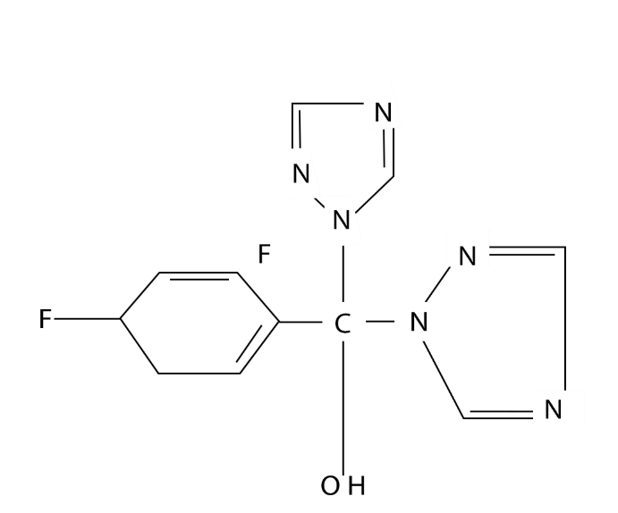
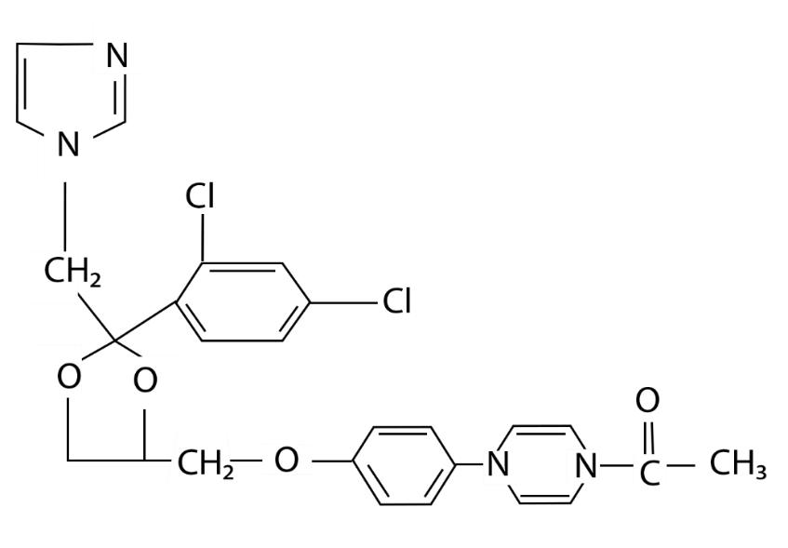

Fluconazole
Ketoconazole

Fig 1.2 illustrating the structural difference between the imidazoles and the triazoles.

The azole derivatives act by inhibiting the 14-demthylation process of ergosterol synthesis. The 14-demethylation step is cytochrome--p450--dependent, and the azoles selectively bind to the heme fraction of fraction of cytochrome--p450, thereby interrupting some essential oxidase reactions. This leads to the blockage of ergosterol synthesis, and accumulation of 14-methyl sterols.
Clotrimazole is available in the forms of creams and pessaries for tropical treatment of superficial fungal and vaginal yeast infections. It has the same spectrum of activity as the polyene, nystatin. But poor systemic absorption coupled with gastrointestinal distress is responsible for the limited systemic use of clotrimazole.
Miconazole is used topically for the treatment of vaginal yeast infections. Its spectrum of activity is similar to that of nystatin. It is also active against Trichophyton and Epidermophyton species. Although miconazole is available for intravenous administration, this form is discouraged because of severe effects such as cardiotoxicity, thrombophlebitis and suppression of bone marrow.
Ketoconazole is administered orally and has a spectrum of antifungal activity that is similar to that of nystatin. Agents such as antacids and H₂ antagonists, which increase the pH of the stomach, reduce the absorption of ketoconazole, and should not be used concurrently. Ketoconazole also interacts with other drugs such as rifampicin and oral anticoagulants.
Fluconazole is available for both oral and intravenous administration. It is active against candida species, Crytpococcus neoformans, Coccidioides immitis and Histoplasma capsulatum.
Itraconazole is administered orally. It is active against the same organisms that are affected by fluconazole. In addition, it inhibits the Aspergillus species and Blastomyces dermatiditis. Antacids can decrease the absorption of itraconazole.
1.2.2.2 Allylamines
In this group, two main drugs are currently in use. These in terbinafine, administered orally, and naftidine, a topical agent. The compounds interfere with ergosterol biosynthesis in dermatophytes by inhibiting the enzyme, squalene epoxidase, which is involved in the production of ergosterol from squalene present in the fungal cell wall. These agents are active against dermatophytes, but have very poor effect on yeasts.
1.2.2.3 Thiocarbamates
These include tolnaftate and tolciclate. Their mechanism of action is similar to the allylamines. They are used topically for the treatment of infections due to dermatophytes, but they are not very active against yeasts.
1.2.2.4 Morpholines
A typical example in this group is the amorolfine. It is highly active against dermatophytes, but has moderate activity against yeasts. It acts by inhibiting enzymes such as Δ₁₄ reductase and Δ₇ Δ₈-isomersase, which are involved in ergosterol biosynthesis. Like the other anti -dermatophytes, amorolfine is available for topical application.

1.4 Inhibitors of nucleic acid synthesis
The only antifungal agent in this group, which is currently in clinical use is a nucleotide derivative, flucytosine (5-flucytosine). This compound is fluorinated pyrimidine. In susceptible fungi, flucytosine penetrates the fungal cell by means of an enzyme, cytosine permease. Once inside the cell, it is deaminated by cytosine deaminase to 5-flourouracil. This is a false nucleotide, which, if incorporated into RNA, disrupts protein synthesis. As a potent inhibitor of thymidylate synthetase, 5-flourouracil also disrupts DNA synthesis in fungal cells. The selective inhibitory action of flucytosine in fungal cells is due to the fact that cytosine deaminase is not present in human cells. Thedrug has a narrow spectrum of activity, and organisms easily develop resistance to it. It is available orally (often used in combination with other antifungals) for the treatment of infections caused by species of Candida, Cryptococcus and Aspergillus.
Flucytosine induces bone marrow suppression leading to neutropenia, thrombocytopenia or anaemia. Therefore, it is not widely prescribed for clinical use.
1.5 Inhibitors of mitosis
One antifungal agent in this class is a grisan derivative, griseofulvin. It binds specifically to tubulin and so interferes with spindle formation at the mitotic stage of cell division. Griseofulvin is active against the mitotic stage of cell division. Griseofulvin is active against the different dermatophytes that cause skin diseases known variously as tinea captitis, tinea cruris, tinea pedis, tinea manuum, tinea unguium and tinea corporis. It is, however, not effective against candidal infections and systemic fungal infections. Griseofulvin is currently available for oral administration only.

ANTIVIRAL AGENTS
  - Introduction
  - Classification of Antiviral Agents
2.2 Inhibitors of attachment
2.2.1 Neutralizing antibodies
2.2.2 Receptor antagonists
2.3 Inhibitors of penetration and uncoating
2.4 Inhibitors of nucleic acid synthesis
2.4.1 DNA/RNA polymerase inhibitors
2.4.2 Nucleoside reverse transcriptase inhibitors
2.4.3 Non nucleoside reverse transcriptase inhibitors
2.4.4 Nucleotide reverse transcriptase inhibitors
2.5 Protease inhibitors
2.6 Immunomodulators

2.0 Introduction
For many years, virologists and related scientists have succeeded in identifying a wide range of disease - causing viruses. Similar to the situation in the aspects of antibacterial and antifungal therapy, there have been enormous efforts to develop antiviral drugs, which can eliminate most of the invasive viruses. Up till the present moment, treatment of viral diseases has remained largely at the preventive [immunization] and suppressive (inhibitory) levels, with little success in the total eradication of the known disease- causing viruses.
One of the difficulties that have hampered the development of effective antiviral drugs is the fact that viruses are obligate intracellular parasites. In addition, viruses depend entirely on the host cells enzymes and biosynthetic mechanisms for their own replication. Hence drugs aimed at preventing viral replication end up affecting the host in deleterious ways. The success achieved in the development of antiviral drugs, albeit limited, has arisen from the exploitation of the certain virus-specific mechanisms in the process of viral replication.
Viral replication involves the synthesis of DNA or RNA, either of which constitutes the genome in a virus. Based on the type of nucleic acid borne, viruses are broadly classified as DNA or RNA viruses. As regards infections by the DNA Viruses, the DNA, on entering into the host cell’s nucleus, is transcribed into mRNA by action of the host cell’s DNA- dependent RNA polymerase. The mRNA is then translated into virus- specific enzymes and structural proteins, leading to the production of complete DNA viruses capable of infecting other cells. On the other hand, i.e. in infections caused by the RNA viruses, the genome of the RNA virus acts directly as a mRNA and in the host cell, is translated into various enzymes and structural proteins for the production of new viral particles.
The viruses that cause many human diseases such as influenza, measles, poliomyelitis, hepatitis, yellow fever and acquired immune deficiency syndrome [AIDS] are RNA viruses. A few DNA viruses also cause diseases such as small pox, chicken pox, herpes and conjunctivitis. A sub group of the RNA viruses, known as retroviruses, are unique in their genomic transcription. They contain a reverse transcriptase, which may be described as RNA-dependent DNA polymerase. This enzyme utilizes the viral RNA as a template for the production of viral DNA, which is inserted into the host cell’s nucleus. Once incorporated into the host cells genome, the viral DNA is then transcribed into mRNA for the purpose of producing replicates of the RNA virus. The virus that causes AIDS, the Human Immuno deficiency Virus (HIV), is a species of the retrovirus.
In discussing antiviral drugs, a reference to the stages in viral replication is necessary. This would enable one to appreciate the specific modes of action of the individual drugs. The first step in viral replication is attatchment then penetration of the virion into the host cell, and its uncoating. In this process, the viral genome is delivered into the cytoplasm of the host cell. For an RNA virus, the RNA genome remains in the cytoplasm where it is translated into enzymes and viral structural proteins. In the case of a DNA virus, the DNA genome is inserted into the host cell’s nucleus where it takes over the host cell’s transcription and translation machinery for the synthesis of viral nucleic acid, and the production of structural proteins. Subsequently, the new viral genomes and the structural proteins assemble to form fresh viral particles. The virions are released following the lysis and death of the host cell. Released viruses are then available for attatchment to other cells of the host organism and the cycle of replication is repeated
Antiviral drugs act by interfering with different stages in the process of viral replication.
2.1 Classification of Antiviral Agents
Antiviral agents (drugs) are classified according to their modes of action. The description of each drug is limited to its specific mechanism of action and spectrum of activity, with fewer details on its clinical usage.

2.2 Inhibitors of attachment
2.2.1 Neutralizing antibiotics
Purified antiviral gamma globulin would contain antibodies against specific viruses. When administered, the antibodies bind to and form a coat on the virions, thereby preventing direct contact between the viruses and the host’s cells. Administration of specific antibodies, in the form of passive immunization is the oldest form of antiviral therapy. Specific immunoglobulins for treatment of hepatitis B, varicella-zoster and rabies are available.
2.2.2 Receptor antagonists
Substances that are structurally analogous to either the viral attachment protein or the cell receptor may competitively block the interaction of the virus with the cell. The attachment protein of HIV is a glycoprotein called gp120, and its receptor is the CD4 molecule of the T-lymphocyte. Certain peptides have been found to block the glycoprotein or its receptor and are being investigated for potential clinical use in the treatment of AIDS. Polysaccharides such as dextran sulphate and heparan are also known to block viral attachment.
2.3 Inhibitors of penetration and uncoating
The acidic environment of the cytoplasm promotes uncoating of viral particles. Agents, which can neutralize or alkalinize the cytoplasm, will prevent uncoating. Amantadine and rimantadine are organic amines with the ability to lower the acidity of the cytoplasmic compartment. Thus they inhibit viral uncoating. In line with specificity of action of antiviral drugs, amantadine is effective only against influenza A viruses. It is used prophylatically for protection against influenza A infections. Tromantadine, a derivative of amantadine, inhibits the penetration of Herpes simplex virus. Methylisoxazole compounds such as arildone and disoxaril inhibit the uncoating of the picomavirus (an RNA virus).

2.4 Inhibitors of nucleic acid synthesis
As described earlier, the production of viral nucleic acid (DNA and RNA) is a critical stage in viral replication. Drugs which block the synthesis of viral nucleic acid are, therefore, considered as very important agents for controlling viral infections and the consequent diseases.
With the probable exception of foscarnet (phosphonoformate), most of the drugs in this group are nucleoside analogues, i.e they are structurally similar to the purine nucleosides (guanosine and adenine) or the pyrimidine nucleosides (thymidine and cytidine). They can be classified into four sub-groups, namely: DNA/RNA polymerases inhibitors, nucleoside reverse transcriptase inhibitors (NRTIs), non-nucleoside reverse transcriptase inhibitors (NNRTIs) and nucleoside reverse transcriptase inhibitors (NtRTIs). NRTIs, NNRTIs and NtRTIs are typical antiretroviral agents, acting specifically against the HIV-1. Drugs in each of these sub-groups are discussed in the following sections.
2.4.1 DNA/RNA polymerase inhibitors
The chemical structures of members of this group are shown in Fig. 2.1. They include foscarnet, acyclovir, ganciclovir and ribavirin.
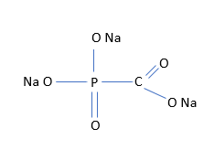
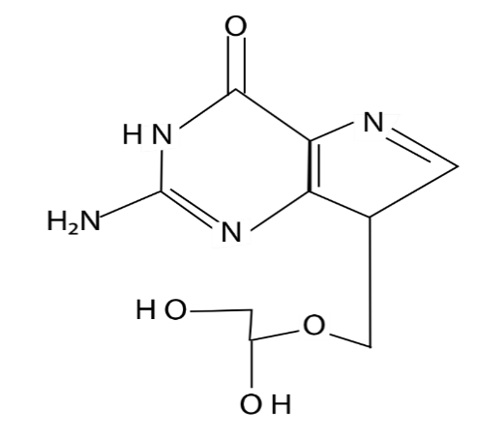

Foscarnet
Ganciclovir
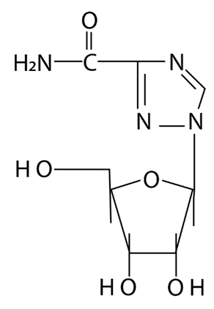
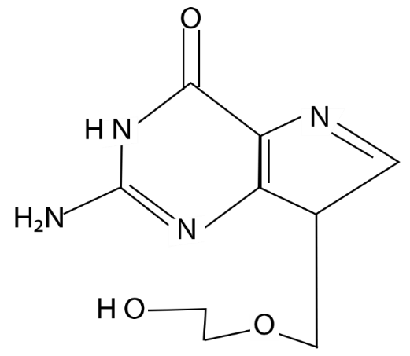

Ribavirin
Acyclovir

Fig.2.1 DNA/RNA polymerase inhibitors

Foscarnet: Foscarnet is an analogue of pyrophosphate. It isa potent inhibitor of DNA polymerase, and is active against cytomegalovirus, a herpes virus that is associated with opportunistic infections in immunocompromised individuals. However, because of itssevere nephrotoxicity, it is reserved for second line therapy if safer alternatives are available.
Acyclovir: Acyclovir is active only in the triphosphate form (i.e. acyclovir triphosphate). Both the host and viral thymidine kinases are involved in converting the drug to its active form. It appears, therefore, that the drug is better activated in an infected host than when it is used prophylactically. Acyclovir triphosphate inhibits DNA polymerase in sensitive viruses. It is highly specific for Herpes simplex 1 and 2 and varicella-zoster viruses. Epstein-Barr virus (a type of herpes virus) is also said to be sensitive to the drug. Acyclovir is available for oral, topical and parenteral administration. Oral acyclovir may be used for the treatment of Herpes genitalis infections, the topical preparations being suitable for cutaneous Herpes simplex infections, while the parenteral form is reserved for severe episodes of Herpes simplex infections in both immunocompromised and non-immunocompromised patients. Resistance of the viruses to acyclovir is attributed to changes in the viral gene that codes for thymidine kinase or DNA polymerase.
Ganciclovir: This compound is a synthetic analogue of guanosine. It is highly active against cytomegalovirus. Cytomegalovirus causes severe retinitis, which often results in blindness. Patients can be saved from loss of sight if they are started early on ganciclovir. The drug is converted to the triphosphate form, which competitively blocks the incorporation of guanosine triphosphate into the viral DNA. In this way, it inhibits DNA replication. Ganciclovir is available for intravenous administration; but severe adverse effects tend to limit its use. It affects the haematopoietic system leading to thrombocytopenia, neutropenia and anaemia.
Ribavirin: Ribavirin is believed to act by alteration of the guanylation process in viral RNA. It is currently only used as an aerosol in the treatment of respiratory viral infections, especially in infants. Ribavirin has proved to be effective in suppressing HIV replication in vitro. But results of clinical trials with the drug have not been so promising.
Idoxuridine (5-iododeoxyuridine): Idoxuridine is metabolized to form the active triphosphate. This is incorporated into viral DNA as a false nucleotide, thereby terminating DNA replication. Because of its high systemic toxicity, the drug is only used topically for the treatment of Herpes simplexkeratitis. Even when used in this way, idoxuridine can cause clouding of the cornea, local irritation and photophobia.
Vidarabine (adenosine arabinose): Vidarabine is phosphorylated in the body to the triphosphate form, which is a potent inhibitor of DNA polymerase. It is believed to impair the initial steps in viral DNA synthesis. It is active against Herpes simplex, varicella-zoster and chicken pox viruses. It is available for intravenous administration, and can also beused for topical application, especially in conjunctivitis, keratitis or corneal ulcer due to Herpes simplex infections.

2.4.2 Nucleoside transcriptase inhibitors
Figure 2.2 is a representation of the structures of some selected nucleoside reverse transcriptase inhibitors.
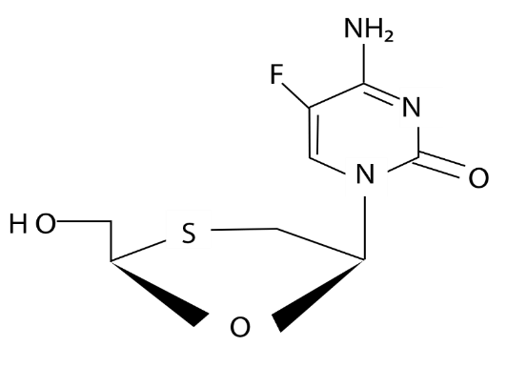
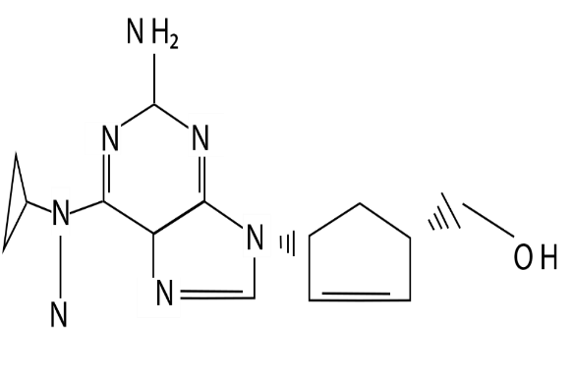

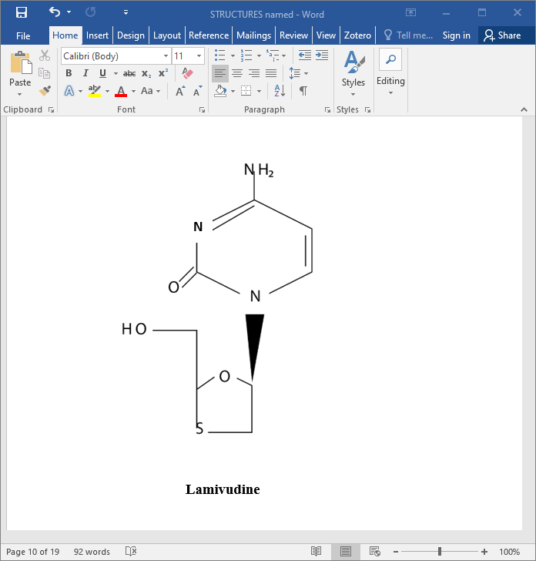
Emptrictabine
Abacavir

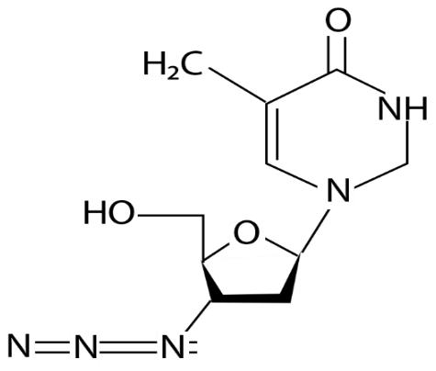
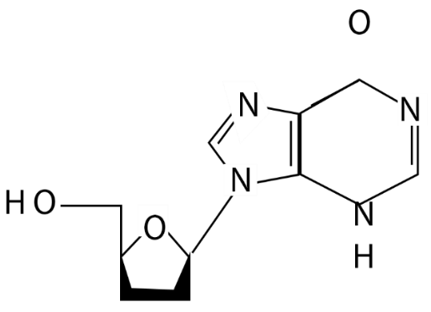
Lamivudine

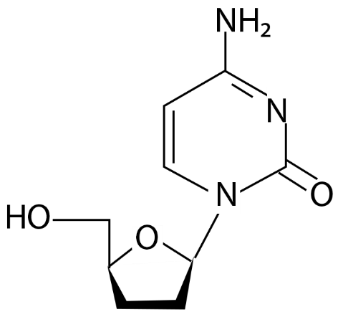
Didanosine
Zidovudine
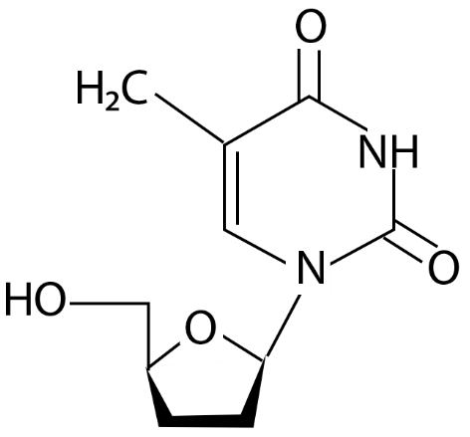

Stavudine
Zalcitabine

Zidovudine (azidothymidine, AZT): Zidovudine was the first drug to be approved by the USA’s Food and Drug Administration (FDA) for use in the treatment of HIV infections and AIDS. It is generally believed that the action of zidovudine lies in its ability to selectively inhibit retroviral reverse transcriptase. This action is attributed to 5’-azidothymidine triphosphates, which is produced in the host’s body.
Competing with cellular thymidine triphosphate, AZT is prefentially incorporated into the growing DNA chain, thereby causing premature termination of chain elongation. The azido group in the AZT molecule increases the lipophilicity of the drug. This allows it to cross cell membranes and also the blood-brain barrier. It has been found that zidovudine is not very effective in the late stages of the disease. Besides, after prolonged use, the virus tends to develop resistance to the drug by mutation. The drug produces severe adverse effects such as bone marrow suppression (with haematopoietic implications leading to anaemia). Other common side effects of AZT include insomnia, mylagia, fever, headache, nausea, diarrhea, abdominal pain and discoloration of finger nails and toe nails. All these factors, and the availability of newer antiretroviral drugs, have limited the use of zidovudine as monotherapy in the treatment of AIDS.
Didanosine (2’, 3’-dideoxyinosine, ddl): A synthetic dideoxyadenosine derivative, didanosine was the second drug to be approved for the treatment of HIV infection and AIDS. In the host’s cells, it is converted to dideoxyadenosine triphosphate (ddATP), in which active form it inhibits the viral reverse transcriptase by competing with natural deoxyadenosine triphosphate (dATP). It also acts as a a DNA chain terminator when incorporated into the growing DNA chain. Thus it effectively inhibits HIV replication. It is used in the management of AIDS patients, even though resistance tends to occur after prolonged usage. Its main advantage is its low toxicity on the erythropoietic system of the bone marrow. However, adverse effects such as insomnia, headache, abdominal pain and hyperuricaemia may occur. Drug interactions have been recorded between didanosine and allopurinol, ketaconazole, itraconazole, ciprofloxacin as well as other antiviral drugs, such as indinavir, zalcitabine and stavudine. Concurrent administration of didanosine with these drugs is not recommended.
Zalcitabine (2’, 3’-dideoxycytidine, ddC): This is a synthetic analogue of cytidine (a pyrimidine nucleoside). Zalcitabine was the third drug to be approved for treatment of HIV infections and AIDS. It is an RNA reverse transcriptase inhibitor with specific action against the HIV. It is available for oral administration, and is used in combination with zidovudine and a protease inhibitor for the treatment of AIDS. It is converted in T-lymphocyte cells into its active triphosphate form, dideoxycytidine triphosphate, ddCTP. This preferentially binds to the HIV reverse transcriptase. It also causes a termination of viral DNA chain elongation by incorporation. The use of zalcitabine has reduced since 2006, because of associated serious adverse effects. The adverse effects include peripheral neuritis, oral ulcers, oesophageal ulcers and, in some cases, pancreatitis.
Abacavir (ABC): This is an analogue of guanosine (a purine nucleoside). It is typically a reverse transcriptase inhibitor and has been found to be very useful in the treatment of HIV infections and AIDS. It is available for oral administration, and is well tolerated. The main side effects associated with abacavir are hypersensitivity reactions. Symptoms of the hypersensitivity reactions include skin rashes, abdominal cramps, diarrhea, pharyngitis and dyspnea. In some cases these reactions may be fatal. For these reasons, the drug is combined with either lamivudine alone or lamivudine and zidovudine. The dose of ABC is generally reduced in the combinations, with anticipated corresponding reduction in side effects. The combinations also help to reduce viral resistance to abacavir. Viral resistance to abacavir can lead to cross resistance to other NRTIs such as didanosine, zalcitabine and lamivudine. However, cross resistance has not been recorded between abacavir and the protease inhibitors.
Lamivudine (22, 32dideoxy-32--thiacytidine, 3TC): Lamivudine, an analogue of cytidine, is an inhibitor of reverse transcriptase of HIV and hepatitis B virus. It is converted, by phosphorylation in the body, to the active inhibitory form, 3TC triphosphate. It is used in low doses for the treatment of chronic hepatitis B. But long term use of the drug causes the emergence of resistant variants of hepatitis B virus. For the treatment of HIV infections and AIDS, lamivudine is combined with zidovudine and/or abacavir. Thelamivudine-zidovudine combination is highly synergistic. Treatment with lamivudine has been shown to restore sensitivity to zidovudine in previously resistant HIV. Lamivudine is also part of the regimen for prevention of mother-to-child- transmission of HIV during pregnancy, labour and delivery, especially in the dual combination with zidovudine.
Lamivudine, used alone or in combination with other NRTIs, is available for oral administration and is well tolerated. It is rapidly absorbed with a bioavailability of about 86 %. It crosses the blood-brain barrier.
Stavudine (22, 32--didehydro-22, 32-dideoxythymidine, d4T): This nucleoside reverse transcriptase inhibitor with specific action against the HIV is an analogue of thymidine. The compound is phosphorylated by cellular kinases into the active triphosphate form. The active form competes for HIV reverse transcriptase with natural thymidine triphosphate, i.e. It acts by competitive inhibition of the viral enzyme. It is also incorporated into the growing chain of viral DNA, thereby terminating the DNA synthesis. Stavudine is particularly antagonistic with zidovudine. AZT inhibits intracellular phosphorylation of d4T, and so concurrent administration of the two drugs is not encouraged. The major adverse effects of stavudine are peripheral neuropathy (which can be reduced by administering lower doses) and lipodystrophy. The drug is contraindicated in pregnancy.
Emptricitabine: This nucleoside reverse transcriptase inhibitor is an analogue of cytidine. It is used specifically for the treatment of HIV infection in humans. Its usefulness for the treatment of chronic hepatitis B virus infections is still under investigation. However, exacerbations of acute hepatitis B have been reported in patients following the withdrawal of emptricitabine. It exerts its effect against HIV by competitive inhibition of the reverse transcriptase enzyme, and thereby prevents viral replication in the host’s cells. The successful control of viral replication results in increased CD4 counts in the patient’s body, which signifies a more stable immune system. Emptricitabine is commercially available as a dual combination with a nucleotide reverse transcriptase inhibitor, tenofovir, or a triple combination with tenofovir and efavirenz (a protease inhibitor). Severe side effects are not usually associated with emptricitabine. Nonetheless, there are a few reported cases of diarrhoea, headache, nausea, skin rash and skin discoloration, which are generally mild.
2.4.3 Non- nucleoside reverse transcriptase inhibitors
The two members of this group of antiretroviral drugs currently in clinical use are nevirapine and efavirenz (fig. 2. 3)

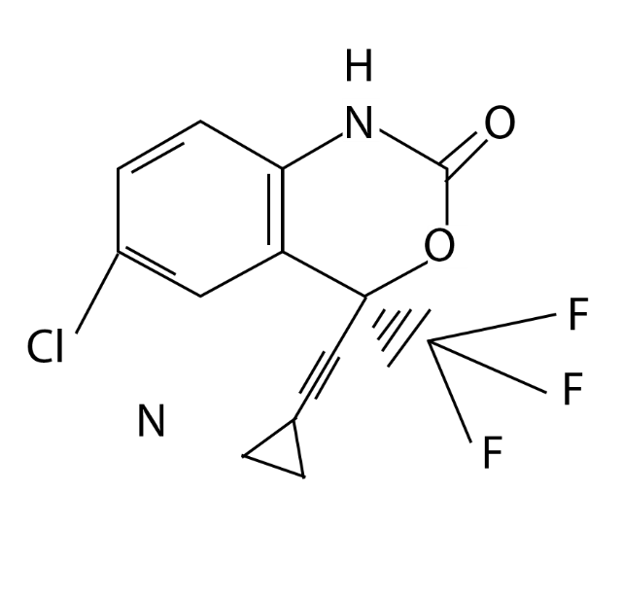
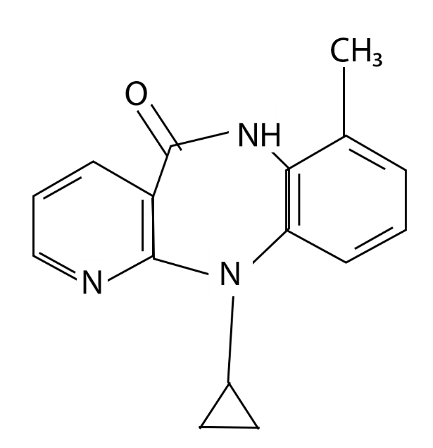

Efavirenz
Nevirapine

Fig. 2.3 Non- nucleoside reverse transcriptase inhibitors

Nevirapine; this drug is used for the treatment of HIV- 1 infections and AIDS. Unlike the NRTIs which bind to the reverse transcriptase enzyme at its active site, the NNRTIs bind to a site on the enzyme, known as NNRTI pocket. HIV- 1 rapidly develops resistance tonevirapine. HIV – 2 is intrinsically resistant to nevirapine because the virus does not possess the specific NNRTI pocket to bind with nevirapine. In order to reduce the rate of resistance by HIV – 1, it would be reasonable to use combinations of nevirapine and other antiretroviral drugs. Unfortunately, nevirapine reduces the plasma levels of several co- administered drugs including such antiretrovirals, as efavirenz, indinavir, lopinavir, nelfinavir and saquinavir. The use of nevirapine as a single drug has been limited to prevention of mother – to- child transmission of HIV – 1, in which case the drug is given as a single dose to both mother and child, followed by a short course of zidovudine. Other problems associated with nevirapine include severe and in some cases, life threatening adverse effects. Nevirapine may cause hypersensitivity reactions, toxic epidermal necrosis, Stevens-Johnson syndrome and severe liver damage.
Efavirenz: Efavirenz is a NNRTI that is used in combination with other antiretroviral drugs for the treatment of HIV-1 infections. Popular drug combinations with efavirenz include efavirenz –lamivudine – zidovudine and efavirenz-tenofovir-emptricitabine. Efavirenz has the same site of action as nevirapine and so cross resistance of HIV often occurs among the NNRTIs. Adverse effects of efavirenz are rare, but include insomnia, headache, dizziness, nausea and skin rash. More severe effects are depression, memory loss and psychotic symptoms, especially in patients with impaired renal or hepatic function. Interactions of efavirenz with other antiviral drugs may necessitate adjustment of doses. Efavirenz lowers plasma levels of most protease inhibitors. The blood levels of indinavir and saquinavir (both protease inhibitors) are so dramatically lowered those combinations of these drugs with efavirenz, or their concurrent administration, is not recommended.

2.4.4 Nucleoside reverse transcriptase inhibitors
Only one drug in this group, tenofovir, is currently being used clinically. Its chemical structure is shown in Fig. 2. 4
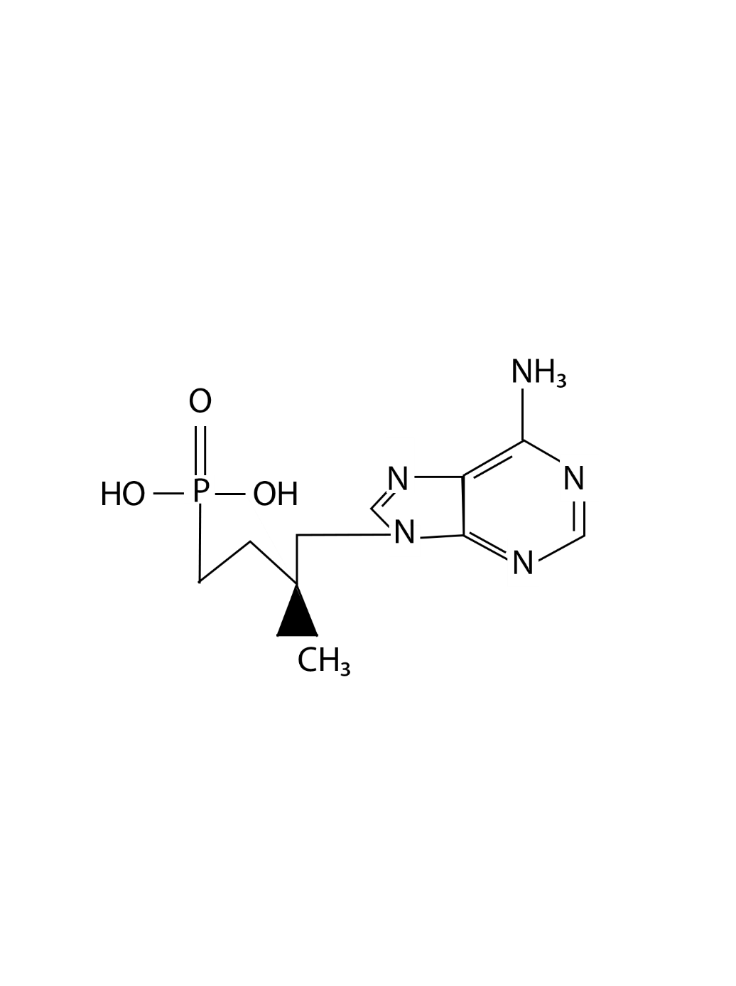

Fig. 2.4 Tenofovir

Tenofovir, shown structurally in Fig. 2.4, is a typical example of the antiretroviral drugs known as nucleotide analogue reverse transcriptase inhibitors (NtRTIs). Tenofovir disoproxil fumarate (TDF) is a prodrug form of the Tenofovir. The drug typically blocks the reverse transcriptase of HIV. It is used in combination with other antiretroviral drugs for the treatment of HIV- 1 infection and AIDS in adults. Double combination products of tenofovir and emtricitabine and triple combinations of tenofovir, emtricitabine and efavirenz are commercially available. The most common side effects of tenofovir include nausea, vomiting, diarrhoea, abdominal pain and flatulence. A more severe adverse effect of tenofovir is renal toxicity due to accumulation of the drug in the proximal tubule of the kidney. Complications may involve acute renal failure.Tenofovir tends to increase the plasma concentrations of didanosine, with implications on both therapeutic value and toxicity.
2.5 Protease inhibitors
Most protease inhibitors are heavy molecules with complex structures. The chemical structures of only a few representative samples of the protease inhibitors have been presented in fig 2.5
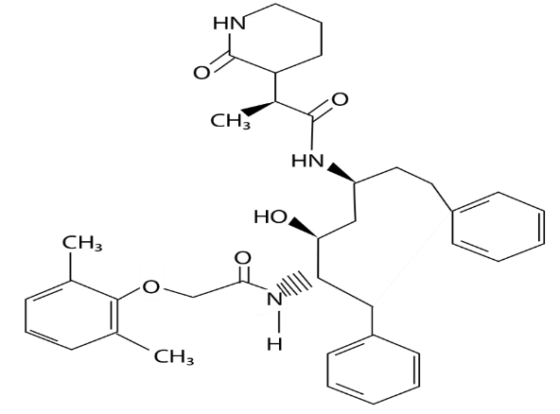
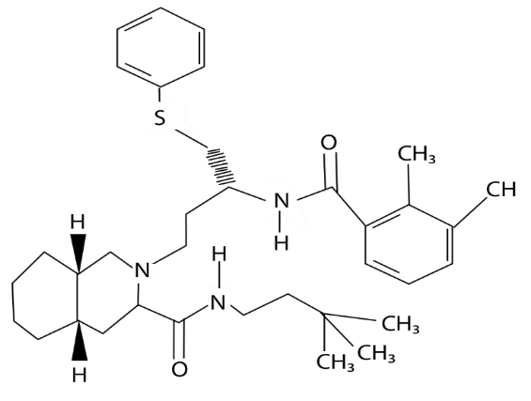

Lopinavir
Nelfinavir

Fig 2.5 Protease inhibitors
Apart from the blocking of nucleic acids synthesis by the action of transcriptase or polymerase inhibitors, the actual translation of mRNA into viral proteins is not a good target for antiviral drugs. The translational processes often result in the formation of polyproteins and glycoproteins which are not utilized by viruses in those forms. Viral proteases break down the polypeptides to the form in which they can serve as the protein coats for the emerging virions. For the glycoproteins to perform their function as organs of attachment, they must undergo appropriate “processing “by the action of the viral proteases. Therefore, inhibition of the proteases responsible for breakdown of viral polyproteins or processing the glycoproteins will block the late stages of viral replication. Protease inhibitors such as indinavir, saquinavir, lopinavir and nelfinavir all have the same mechanism of action. They are useful in the treatment of an advanced HIV disease, especially when combined with the reverse transcriptase inhibitors in the highly active antiretroviral therapy (HAART). Used in this way, the protease inhibitors are believed to reduce the emergence of resistant viral mutants. Ritonavir, a protease inhibitor, is frequently prescribed in HAART. It is used not particularly because of its antiviral action, but for its ability to inhibit a specific host enzyme, cytochrome P450 – 3A4, which metabolizes other protease inhibitors. Inhibition of this metabolic enzyme leads to higher plasma concentrations of the antiviral drugs, thereby improving their clinical efficacy. This is one of the effect; the other other side is that the elevated plasma concentrations of the antiviral drugs bring about a large variety of side effects and sometimes fatal drug interactions. The most common side effects associated with ritonavir therapy are; asthenia, malaise, diarrhoea, nausea, vomiting, dizziness, insomnia and excessive sweating. Other side effects are metabolism- related; hypercholesterolaemia, hypertriglyceridaemia, hyperglycaemia and elevated transaminases.
2.6 Immunomodulators
Any substance, natural or synthetic, which is capable of boosting T-lymphocyte activity , can be used to enhance the body’s immunological response to antigenic agents. In thisregard, interferons (α, β and ¥ sub – types) have attracted much attention. These are immunomodulatory proteins, which have been shown to block viral replication, in vitro. It is expected that they might be used clinically for anti – viral therapy.

